Kubernetes Task-06
Prerequisites
Before starting, verify that your Kubernetes cluster is running.
Step 1: Check your cluster nodes
kubectl get nodes -o wide
Make sure your control-plane and worker nodes show Ready.
Step 2: Create a working directory
Execute these commands on your Kubernetes control-plane machine, where kubectl is configured.
mkdir -p ~/k8s-configmap-secret-labs
cd ~/k8s-configmap-secret-labs
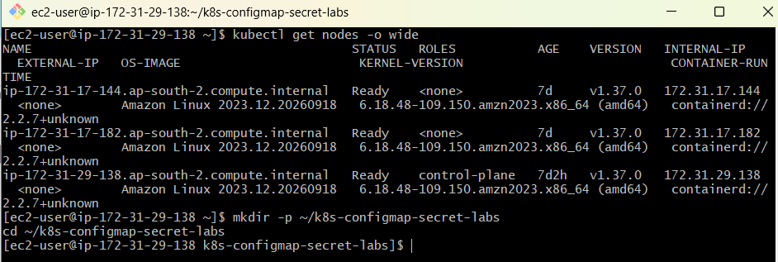
Step 3: Understand the two Kubernetes resources
ConfigMap | Secret
Stores non-sensitive configuration | Stores sensitive information
Examples: app name, port, environment | Examples: username, password, tokens
Supports environment variables and volume mounts | Supports environment variables and volume mounts
Values are stored as plain configuration data | Values may be represented using Base64 in YAML
Important: Base64 is encoding, not encryption. Kubernetes Secrets need appropriate RBAC and encryption at rest for stronger protection. These labs use dummy credentials only.

LAB 1: Create a ConfigMap from a directory and inject environment variables
Task 1
Objective: Create a directory containing multiple configuration files, generate a ConfigMap from those files, and inject the ConfigMap values into a pod as environment variables.
Architecture
Configuration directory
APP_NAME • APP_ENV • APP_PORT
ConfigMap
app-directory-config
Pod
Configuration injected as environment variables
Step 1: Create a directory
mkdir -p lab1/config
cd lab1
Step 2: Create multiple configuration files
We'll create three files, each containing one configuration value.
echo "HiringApp" > config/APP_NAME
echo "production" > config/APP_ENV
echo "8080" > config/APP_PORT
Verify the files:
ls -l config/
Expected files:
APP_NAME
APP_ENV
APP_PORT
Check their contents:
cat config/*
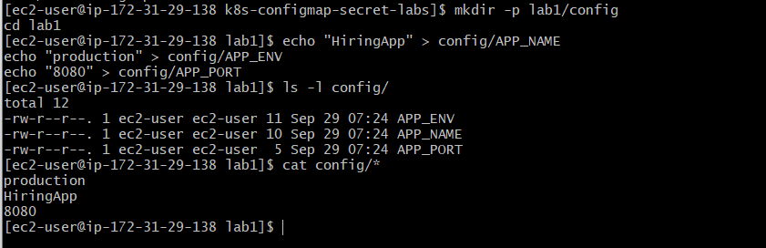
Step 3: Create a ConfigMap from the directory
kubectl create configmap app-directory-config \
--from-file=config/
Expected output:
configmap/app-directory-config created
When Kubernetes creates a ConfigMap from a directory, each valid filename becomes a key, and the contents of that file become its value.
Verify:
kubectl get configmaps
kubectl describe configmap app-directory-config
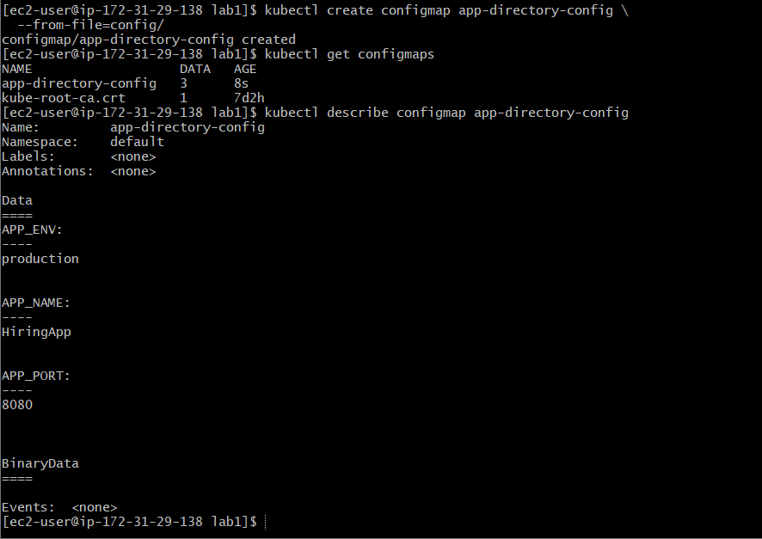
Step 4: Create a pod YAML file
vi lab1-pod.yaml
Insert the following configuration:
apiVersion: v1
kind: Pod
metadata:
name: lab1-configmap-pod
spec:
containers:
- name: config-container
image: busybox:1.36
command: ["sh", "-c", "sleep 3600"]
envFrom:
- configMapRef:
name: app-directory-config
The envFrom field imports all valid ConfigMap keys as environment variables into the container.
Step 5: Deploy the pod
kubectl apply -f lab1-pod.yaml
Verify:
kubectl get pods
Wait until lab1-configmap-pod shows Running.
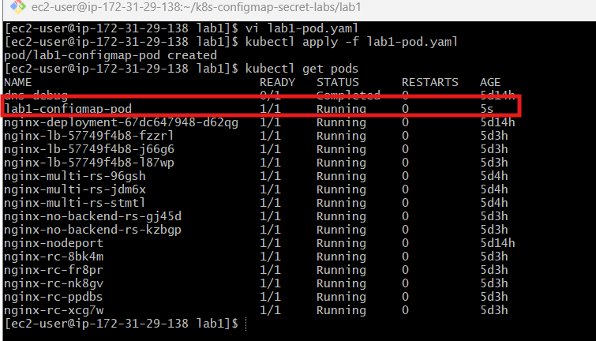
Step 6: Verify environment variables
Execute:
kubectl exec lab1-configmap-pod -- env
You should find the following variables:
APP_NAME=HiringApp
APP_ENV=production
APP_PORT=8080
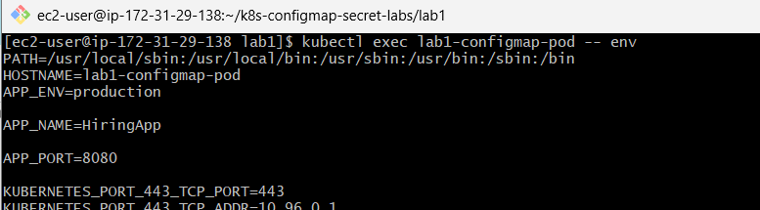
You can also verify individual variables:
kubectl exec lab1-configmap-pod -- \
printenv APP_NAME
Expected output:
HiringApp
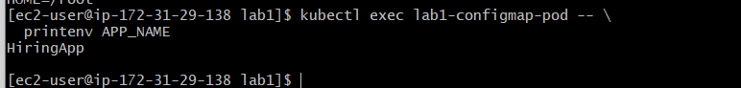

LAB 2: Create a ConfigMap from a file and mount it as a volume
Task 2
Objective: Create a ConfigMap using a configuration file and mount it into a container so that the application can read the configuration as a file.
Architecture
application.properties
ConfigMap
app-file-config
Pod
/etc/app-config/
application.properties
Step 1: Create a directory and configuration file
mkdir lab2
cd lab2
Create a configuration file:
vi application.properties
Insert:
app.name=HiringApplication
app.environment=production
server.port=8080
logging.level=INFO
Save the file.
Step 2: Create a ConfigMap from the file
kubectl create configmap app-file-config \
--from-file=application.properties
Verify:
kubectl get configmap app-file-config -o yaml
The ConfigMap will contain a key named application.properties with the entire contents of your file.
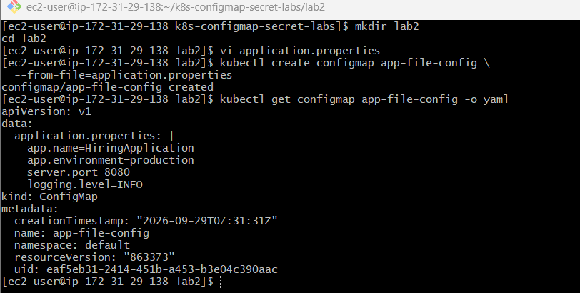
Step 3: Create the pod YAML file
vi lab2-pod.yaml
Insert:
apiVersion: v1
kind: Pod
metadata:
name: lab2-configmap-volume-pod
spec:
containers:
- name: config-container
image: busybox:1.36
command: ["sh", "-c", "sleep 3600"]
volumeMounts:
- name: app-config-volume
mountPath: /etc/app-config
readOnly: true
volumes:
- name: app-config-volume
configMap:
name: app-file-config
Here, volumes references the ConfigMap, and volumeMounts determines where its data will appear inside the container.
Step 4: Deploy the pod
kubectl apply -f lab2-pod.yaml
Check its status:
kubectl get pod lab2-configmap-volume-pod
Step 5: Verify the mounted configuration file
List the directory inside the pod:
kubectl exec lab2-configmap-volume-pod -- \
ls -l /etc/app-config/
Expected file:
application.properties
Read the configuration:
kubectl exec lab2-configmap-volume-pod -- \
cat /etc/app-config/application.properties
Expected output:
app.name=HiringApplication
app.environment=production
server.port=8080
logging.level=INFO
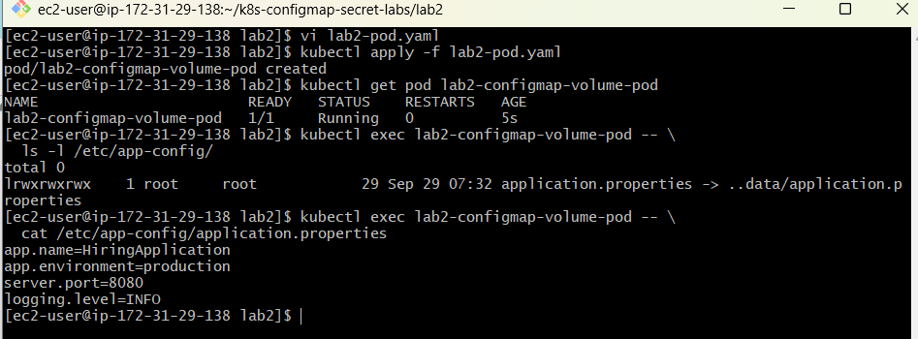
LAB 3: Create a Secret and inject username and password as environment variables
Task 3
Objective: Create a Kubernetes Secret containing a username and password. Inject these values into a pod as environment variables.
Architecture
Secret
db-login-secret
username • password
Pod
lab3-secret-env-pod
DB_USERNAME
DB_PASSWORD
Step 1: Create the lab directory
mkdir lab3
cd lab3
Step 2: Create a Secret
Execute:
kubectl create secret generic db-login-secret \
--from-literal=username=admin \
--from-literal=password=DemoPass123
Expected output:
secret/db-login-secret created
These are dummy credentials. In production, avoid passing real passwords directly on the command line because they may be exposed through shell history or process inspection.
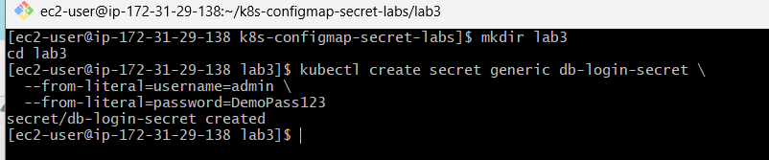
Step 3: Verify the Secret
kubectl get secrets
Check the Secret details:
kubectl describe secret db-login-secret
Expected information:
Name: db-login-secret
Type: Opaque

Data
====
password: 11 bytes
username: 5 bytes
Kubernetes does not display the actual Secret values in the describe output.
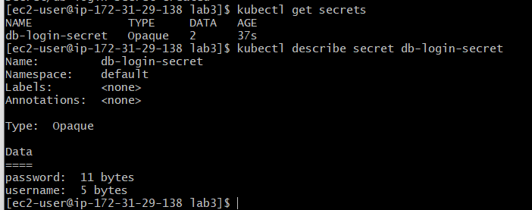
Step 4: Create a pod YAML file
vi lab3-pod.yaml
Insert:
apiVersion: v1
kind: Pod
metadata:
name: lab3-secret-env-pod
spec:
containers:
- name: secret-container
image: busybox:1.36
command: ["sh", "-c", "sleep 3600"]
env:
- name: DB_USERNAME
valueFrom:
secretKeyRef:
name: db-login-secret
key: username

- name: DB_PASSWORD
valueFrom:
secretKeyRef:
name: db-login-secret
key: password
Explanation:
- env defines environment variables.
- valueFrom specifies an external source.
- secretKeyRef retrieves values from a Kubernetes Secret.
- key specifies which Secret value to retrieve.
Step 5: Deploy the pod
kubectl apply -f lab3-pod.yaml
Verify:
kubectl get pod lab3-secret-env-pod
Wait until the pod is running.
Step 6: Verify the environment variables
Check the username:
kubectl exec lab3-secret-env-pod -- \
printenv DB_USERNAME
Expected output:
admin
Check the password:
kubectl exec lab3-secret-env-pod -- \
printenv DB_PASSWORD
Expected output:
DemoPass123
Only display Secret values like this in a disposable lab environment.
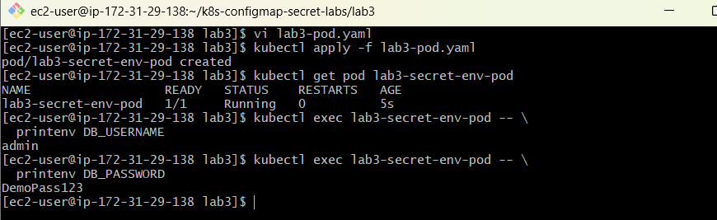

LAB 4: Create a Secret using YAML and mount it as a volume
Task 4
Objective: Create a Secret using a YAML manifest, mount it inside a pod, and verify that the Secret values are available as individual files.
Step 1: Create the directory
mkdir lab4
cd lab4
Step 2: Create the Secret YAML file
vi db-secret.yaml
Insert:
apiVersion: v1
kind: Secret
metadata:
name: db-volume-secret
type: Opaque
stringData:
username: admin
password: DemoPass456
The stringData field allows you to provide plain-text values without manually encoding them.
Kubernetes processes these values into the Secret's data field when creating the resource.
Do not commit YAML files containing real passwords to Git.
Step 3: Create the Secret
kubectl apply -f db-secret.yaml
Expected output:
secret/db-volume-secret created
Verify:
kubectl get secret db-volume-secret
Expected information:
NAME TYPE DATA
db-volume-secret Opaque 2
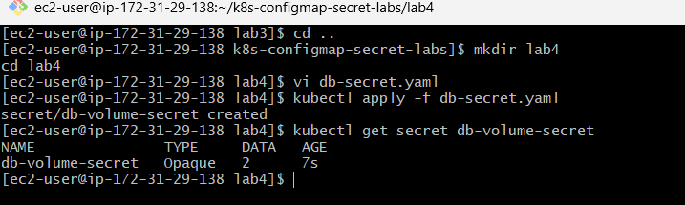
Step 4: Create the pod YAML file
vi lab4-pod.yaml
Insert:
apiVersion: v1
kind: Pod
metadata:
name: lab4-secret-volume-pod
spec:
containers:
- name: secret-container
image: busybox:1.36
command: ["sh", "-c", "sleep 3600"]
volumeMounts:
- name: secret-volume
mountPath: /etc/db-credentials
readOnly: true

volumes:
- name: secret-volume
secret:
secretName: db-volume-secret
How this works:
Kubernetes retrieves the Secret and projects its keys into the specified directory.
The resulting directory will contain:
/etc/db-credentials/
username
password
Each file contains the value associated with its corresponding Secret key.
Step 5: Deploy the pod
kubectl apply -f lab4-pod.yaml
Verify:
kubectl get pod lab4-secret-volume-pod
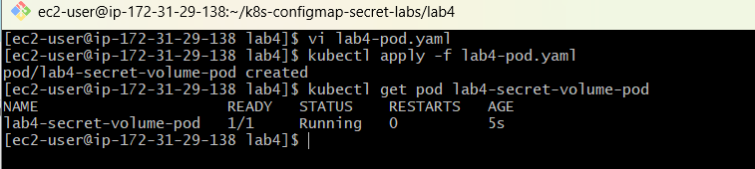
Step 6: Verify the Secret files
List the files:
kubectl exec lab4-secret-volume-pod -- \
ls -l /etc/db-credentials/
Expected filenames:
username
password
Read the username:
kubectl exec lab4-secret-volume-pod -- \
cat /etc/db-credentials/username
Expected output:
admin
Read the password:
kubectl exec lab4-secret-volume-pod -- \
cat /etc/db-credentials/password
Expected output:
DemoPass456
Step 7: Verify the volume configuration
kubectl describe pod lab4-secret-volume-pod
Look for the Mounts and Volumes sections.
The output should show that the Secret is mounted at /etc/db-credentials.
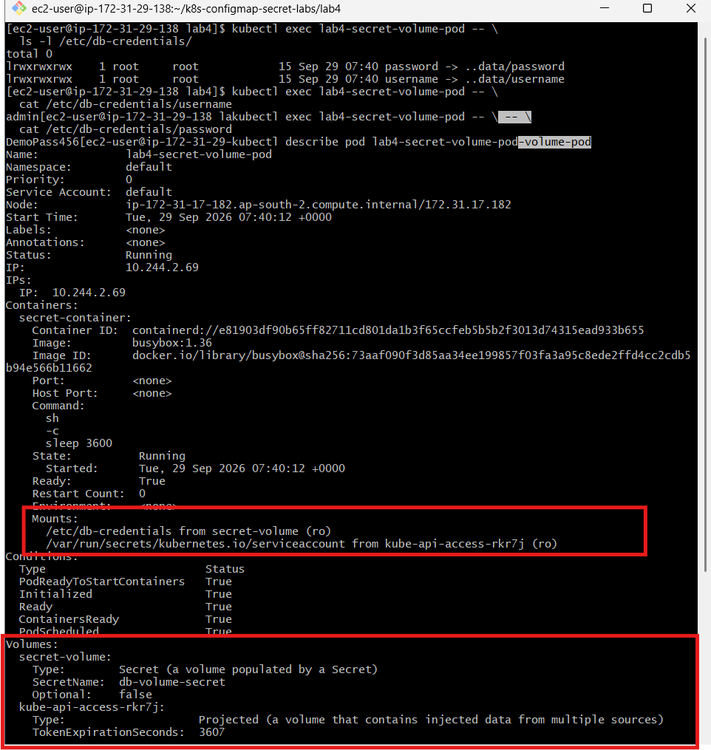
LAB 5: Inject a ConfigMap as environment variables and a Secret as files into the same pod
Task 5
Combined lab
Objective: Create one pod that uses a ConfigMap for application environment variables and a Secret for sensitive information mounted as files.
This is a common Kubernetes application configuration pattern.
Combined architecture
ConfigMap
combined-app-config
APP_NAME
APP_ENV
APP_PORT
Secret
combined-db-secret
username
password
Environment variables
Mounted files
lab5-combined-pod
One container using both configuration sources
Step 1: Create the directory
mkdir lab5
cd lab5
Step 2: Create the ConfigMap YAML
vi combined-configmap.yaml
Insert:
apiVersion: v1
kind: ConfigMap
metadata:
name: combined-app-config
data:
APP_NAME: "HiringApplication"
APP_ENV: "production"
APP_PORT: "8080"
Create the ConfigMap:
kubectl apply -f combined-configmap.yaml
Verify:
kubectl get configmap combined-app-config
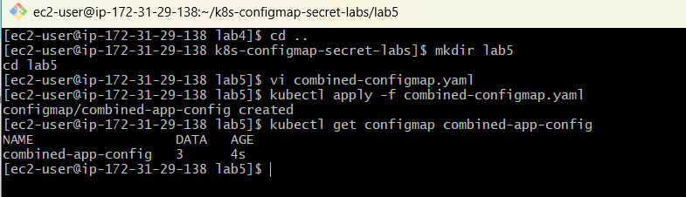
Step 3: Create the Secret YAML
vi combined-secret.yaml
Insert:
apiVersion: v1
kind: Secret
metadata:
name: combined-db-secret
type: Opaque
stringData:
username: admin
password: DemoPass789
Create the Secret:
kubectl apply -f combined-secret.yaml
Verify:
kubectl get secret combined-db-secret
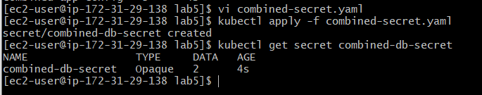
Step 4: Create the combined pod YAML
vi lab5-pod.yaml
Insert:
apiVersion: v1
kind: Pod
metadata:
name: lab5-combined-pod
spec:
containers:
- name: combined-container
image: busybox:1.36
command: ["sh", "-c", "sleep 3600"]

# Inject ConfigMap as environment variables
envFrom:
- configMapRef:
name: combined-app-config

# Mount Secret as files
volumeMounts:
- name: db-secret-volume
mountPath: /etc/db-secret
readOnly: true

volumes:
- name: db-secret-volume
secret:
secretName: combined-db-secret
Notice the two separate configurations:
- envFrom imports the ConfigMap as environment variables.
- volumeMounts and volumes mount the Secret as files.
Step 5: Deploy the pod
kubectl apply -f lab5-pod.yaml
Verify:
kubectl get pod lab5-combined-pod
Wait for the pod to reach Running.
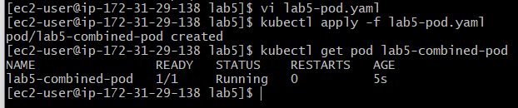
Step 6: Verify the ConfigMap environment variables
kubectl exec lab5-combined-pod -- \
printenv APP_NAME
Expected output:
HiringApplication
Check the remaining variables:
kubectl exec lab5-combined-pod -- \
printenv APP_ENV
production
kubectl exec lab5-combined-pod -- \
printenv APP_PORT
8080
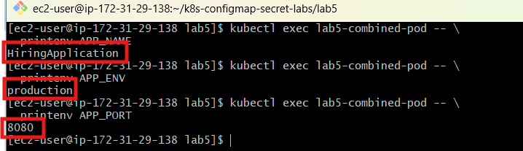
Step 7: Verify the Secret files
List the Secret directory:
kubectl exec lab5-combined-pod -- \
ls -l /etc/db-secret/
Expected filenames:
username
password
Check the username:
kubectl exec lab5-combined-pod -- \
cat /etc/db-secret/username
Expected output:
admin
Check the password:
kubectl exec lab5-combined-pod -- \
cat /etc/db-secret/password
Expected output:
DemoPass789
Step 8: Verify both configurations in one command
kubectl exec lab5-combined-pod -- sh -c '
echo "Application configuration:"
printenv APP_NAME
printenv APP_ENV
printenv APP_PORT

echo "Secret files:"
ls /etc/db-secret/
'
Expected output:
Application configuration:
HiringApplication
production
8080
Secret files:
password
username
